E-Paper - Display Text

Materials

* AmebaD [ [AMB23](https://www.amebaiot.com/amebad/#rtk_amb23) / [AMB21](https://www.amebaiot.com/amebad/#rtk_amb21) / [AMB22](https://www.amebaiot.com/amebad/#rtk_amb22) / [BW16](https://www.amebaiot.com/amebad/#partner_bw16) ] x 1
* Waveshare 2.9inch E-Paper HAT (D) x 1

Example

In this example, we use the Ameba RTL8722 module to connect to a Waveshare 2.9-inch e-Paper module to display a few QR codes. The display uses the flexible substrate as base plate, with an interface and a reference system design.  
The 2.9” active area contains 296 x 128 pixels and has 1-bit white/black full display capabilities. An integrated circuit contains gate buffer, source buffer, interface, timing control logic, oscillator, etc… are supplied with each panel.  
You may refer to the official [2.9 inch e-Paper HAT(D) datasheet](https://www.waveshare.net/w/upload/b/b5/2.9inch_e-Paper_(D)_Specification.pdf) to know more information about this module. Front view of the e-Paper Module:

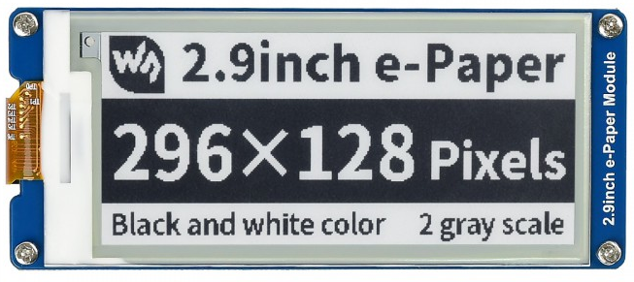

**AMB21/AMB22 wiring diagram:**

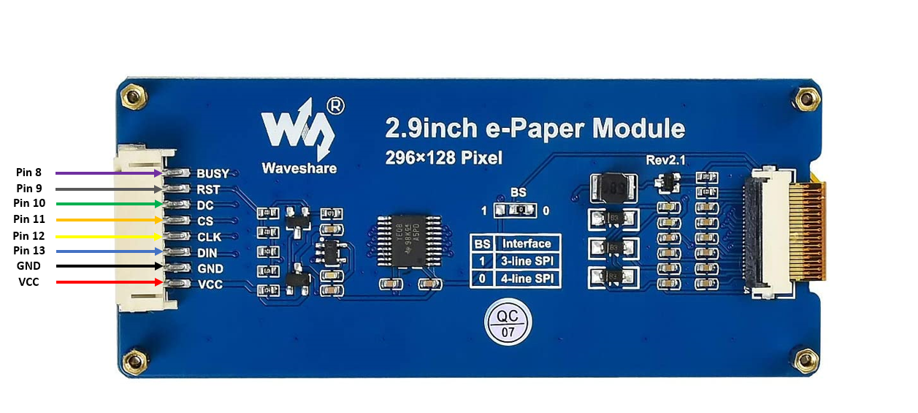

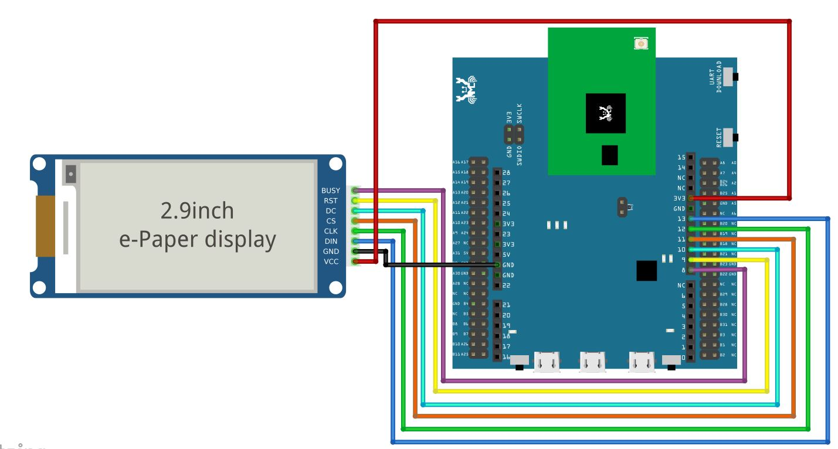

**AMB23 wiring diagram:**

**BW16 Wiring Diagram:**

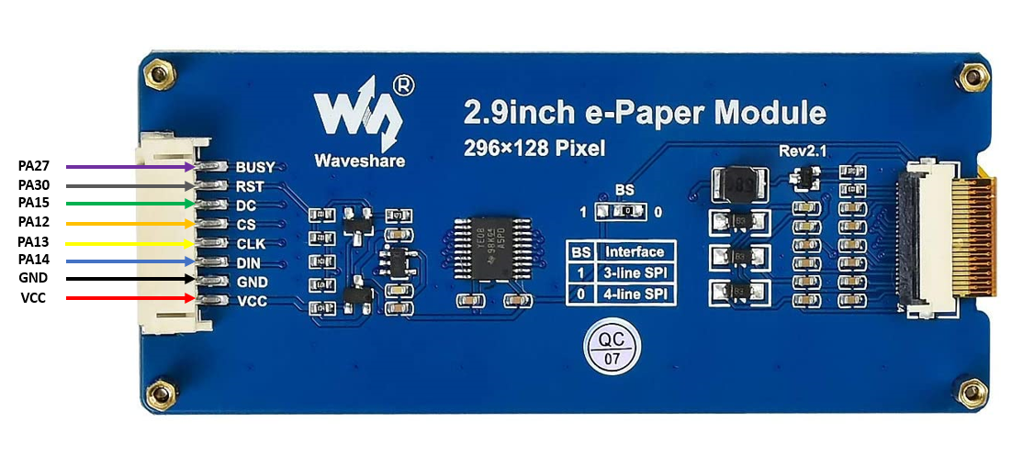

**BW16-TypeC Wiring Diagram:**

Download the Eink zip library, AmebaEink.zip, at <https://github.com/ambiot/ambd_arduino/tree/master/Arduino_zip_libraries>  
Then install the AmebaEink.zip. Open the “DisplayText” example in “File” → “Examples” → “AmebaEink” → “EinkDisplayText”:

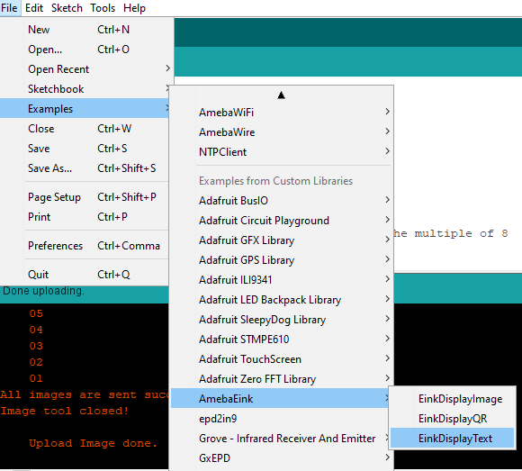

Upload the code to the board and press the reset button after uploading is done. You will find these texts displayed on the board:

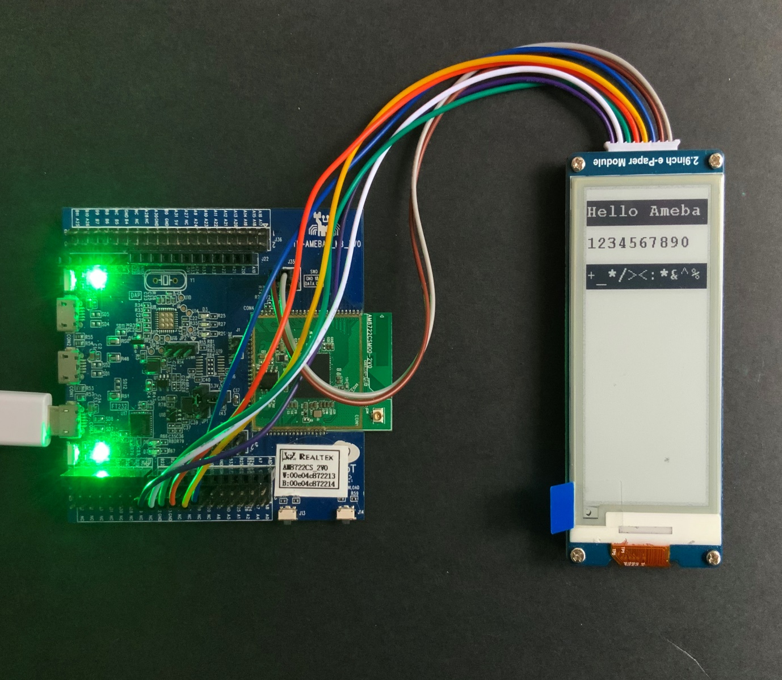

Code Reference

[1] We use Good Display GDEH029A1 2.9 Inch / 296×128 Resolution / Partial Refresh Arduino Sample Code to get the e-Paper successfully Display:  
<http://www.good-display.com/product/201.html>